ANALYSIS OF NANOCOMPOSITES WITH PIEZOELECTRIC PROPERTIES COMPOUNDS OF POLY (VINYLIDENE FLUORIDE) AND GRAPHENE OXIDE

Anna L. Souzaª, Wagner M. Pachekoskiª

ª Federal University of Santa Catarina (UFSC), Department of Mobility Engineering - Technological Center of Joinville, Joinville – SC, Brazil
Email: annaluizagtba@gmail.com
wagner.pachekoski@ufsc.br *

Poly (vinylidene fluoride) (PVDF) is a semicrystalline thermoplastic fluoropolymer, with crystallinity ranging between 40 and 60%, which can crystallize in four possible modifications, named alpha (α), beta (β), gamma (γ) and delta (δ). The β phase guarantees pyro and piezoelectric properties, that is, it converts mechanical energy into electrical energy and vice versa. One way to obtain the β phase is using a solution with dimethyl formamide (DMF) at a controlled temperature. The addition of graphene oxide (GO) to this solution can significantly increase the dielectric properties of PVDF and impact changes in mechanical properties. Therefore, this work has the general objective of analyzing nanocomposites with piezoelectric properties, in addition to presenting the analysis of the GO dispersion in the polymeric solution and the thermal, morphological and electrical characterization of the resulting nanocomposites. The proposed methodologies were the generation of films and electrospinning, these requiring different realization processes. The best dispersion method found for the GO was direct dispersion in the solvent via cleaning ultrasound and the electrical characterization was performed using an oscilloscope. As a result, the nanocomposite film generated a maximum voltage value of 13 V and showed agglomeration of the GO in its morphology. In comparison, the electrospun blanket generated a voltage of 33 V for the material with the addition of oxide, in addition to providing better dispersion in the final nanocomposite.

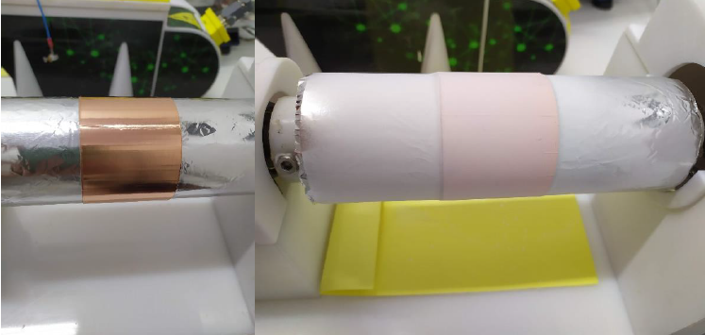
Figure 1. Arrangement used for deposition of polymeric blankets in the electrospinning method.

Acknowledgment:
The authors thank the National Council for Scientific and Technological Development (CNPq).

References:
[1] N. An, et al. Polymer,132, (2014)
[2] C. Botas, et al. Elsevier, 275 (2011)
[3] M. G. Broadhurst; G. T. Davis. Ferroelectrics, 60, (1984)

