Solution-processable triphenylamine-based Schiff base oligomer containing thiophene-benzothiadiazole moieties in the backbone

Ignacia A. Stepanovicª, César Saldias^{b}, Alain Tundidor-Camba^{c}, Claudio A. Terraza^{a,d}, Patricio A. Sobarzoª*

ª Research Laboratory for Organic Polymers (RLOP), Facultad de Química y de Farmacia, Pontificia Universidad Católica de Chile, Santiago, Chile. ^{b} Departamento de Fisicoquímica, Pontificia Universidad Católica de Chile, Santiago, Chile. ^{c} Department of Chemical & Biological Engineering, The University of Alabama, Alabama, United States. ^{d} UC Energy Research Center, Pontificia Universidad Católica de Chile, Santiago Chile.
Email: psobarzo@aol.com

New triphenylamine-based Schiff base oligomer (o-SBp-TPA-TBT) containing thiophene-benzothiadiazole units in the main chain was synthesized by Suzuki-Miyaura cross coupling polycondensation reaction and characterized by FT-IR and NMR spectroscopy [1,2]. o-SBp-TPA-TBT was obtained as a soluble material in common organic solvents due the presence of triphenylamine units [3]. The optical properties of this Schiff base oligomer showed a broad absorption band (506 nm) and emission (653 nm) in the UV-visible region, exhibiting photoluminescence with a large Stokes shift (116 nm). This new π-conjugated material has a low optical bandgap value (1.89 eV), suggesting semiconducting behavior with potential applications in optoelectronic devices.

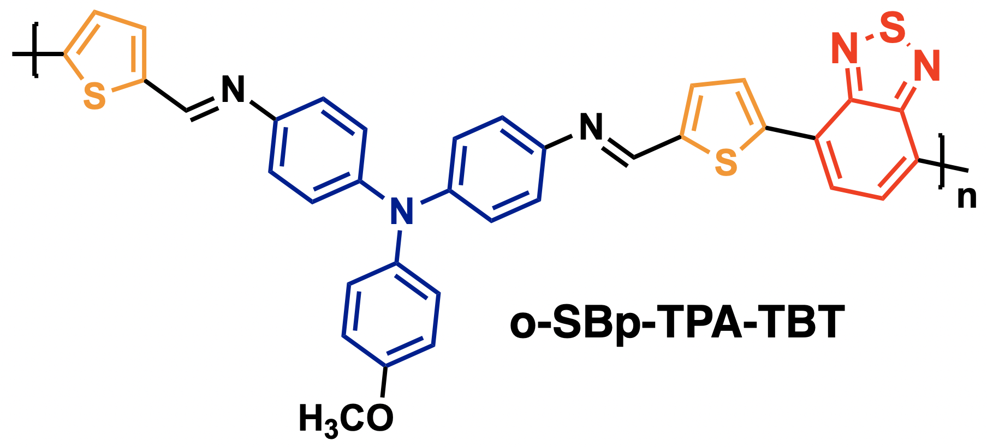

Figure 1. Triphenylamine-based Schiff base oligomer containing thiophene and benzo[c][1,2,5]thiadiazole units.

Acknowledgments: the authors acknowledge the financial assistance provided by ANID-FONDECYT N° 3220883, 1230090.

References: [1] C.O. Sánchez, J.C. Bèrnede, L. Cattin, M. Makha, N. Gatica, Schiff base polymer based on triphenylamine moieties in the main chain. Characterization and studies in solar cells, Thin Solid Films, 562, 495 (2014). [2] R.A. Hauyon, D. Fuentealba, N. Pizarro, M.C. Ortega-Alfaro, V.M. Ugalde-Saldívar, P.A. Sobarzo, J. Medina, L. García, I.A. Jessop, C.M. González-Henríquez, A. Tundidor-Camba, C.A. Terraza, New light-Green thermally activated delayed fluorescence polymer based on dimethylacridine triphenyltriazine light-emitting unit and tetraphenylsilane moiety as non-conjugated backbone, Opto- Polymers, 15, 67 (2023). [3] L. Chang, Y. Hou, J. Bai, H. Xu, Y. Zhang, S. Miao, C. Wang, Optoelectronic/memory storage properties of triphenylamine-based dual-function electrochromic materials, Materials Chemistry and Physics. 275, 125196 (2022).

