**Production of poly(3-hydroxybutyrate-*co*-hydroxyvalerate) with different molecular weight and 3HV fraction by *Azotobacter vinelandii* OP in continuous cultures**

Andrés Péreza,b, Viviana Urtuviaa, Alvaro Díaz Barreraa

a *Pontificia* *Universidad Católica de Valparaíso, Facultad de Ingeniería, Escuela de Ingeniería Bioquímica, Valparaíso, Chile.*

*b Universidad Técnica Federico Santa María, Valparaíso, Chile.*

*Email:* [*aaperezb17@gmail.com*](mailto:aaperezb17@gmail.com)

**Introduction**: The production of polyhydroxyalkanoates (PHA), particularly the copolymer poly(3-hydroxybutyrate-*co*-hydroxyvalerate) (PHBV), is of great interest due to its plastic-like characteristics similar to petrochemical-based plastics, as well as its biodegradability and biocompatibility, making useful for biomedical applications [1]. *Azotobacter vinelandii* produce PHBV using the precursor valeric acid. In batch cultures conducted in a bioreactor the agitation rate influence the composition of the polymer [2]. The aim was evaluate the effect of low agitation on the molecular weight and 3HV fraction of PHBV produced by *A vinelandii* in chemostat cultures**Methodology**: Chemostat cultures of *A. vinelandii* OP were performed in 3 L Applikon bioreactor with 1.5 L working volume at different agitation rates. Cultures were maintained at 30°C, with 1 vvm aeration. Sucrose (20 g L-1) was used as the carbon source, and valeric acid (1,0 g L-1) was added as a precursor for PHBV synthesis. The monomeric composition was quantified by Gas Chromatography and the Molecular weight (Mw) was determined by Gel Permeation Chromatography coupled to HPLC [2].

**Results**: Figure 1 shows , the 3HV fraction was higher at low agitation, reaching the highest level reported for *A. vinelandii* OP cultures compared to the 20 mol % previously described [1,2]. Additionally, the higher molecular weight was obtained in cultures under steady-state at 150 and 250 rpm, comparable to *A. vinelandii* OP [2]. At 450 rpm, the molecular weight was 270±80 kDa, similar to that of *A. vinelandii* OP in extended batch cultures [2]. The polydispersity indices (PI) indicate greater homogeneity at lower agitation rates.

**Conclusion**: Operating the chemostat at a lower agitation rate produces PHBV with higher molecular weight, homogeneity, and a higher 3HV fraction. These improved properties make it ideal for biotechnological applications.

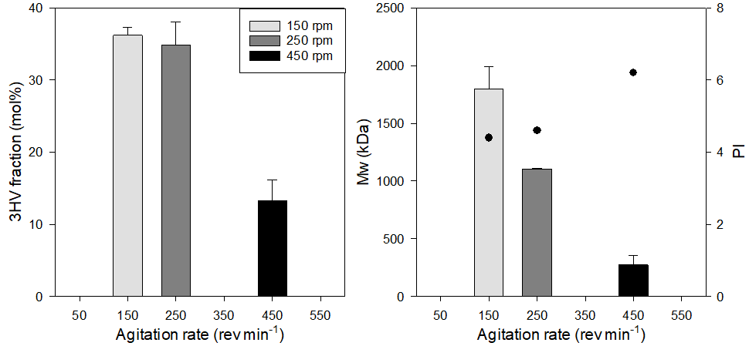

Figure 1. The 3HV fraction, molecular weight and PI (black circles) at different agitation rates in *A. vinelandii* OP continuous cultures.

Acknowledgments:

The authors thank the project: Beca ANID Doctorado Nacional N°21211820. Fondecyt Regular N° 1231075

References:

[1] Rivera-Briso AL, Serrano-Aroca Á. Poly(3-Hydroxybutyrate-*co*-3-Hydroxyvalerate): Enhancement Strategies for Advanced Applications. Polymers (Basel). 732 (2018)

[2] Urtuvia V., Ponce B., Andler, R. Peña C., Díaz-Barrera A*.* Extended batch cultures for poly(3-hydroxybutyrate-*co-*3-hydroxyvalerate) (PHBV) production by *Azotobacter vinelandii* OP growing at different aeration rates. *3 Biotech* **12**, 304 (2022)