**Study of the Influence of Recyclable Polymers on the Production of Multilayer Films by Extrusion and Blown Film Techniques and Their Properties.**

Johan garciaa, Omar Mayorgab, Nora Aranburub, Gonzalo Guerricab

a University of the Basque Country, Engineering, Cobbler, Bilbao, Spain.

b University of the Basque Country, Chemistry, Polymat Group, San Sebastián, Spain.

Email: jgarcia500@ikasle.ehu.eus.

The exponential increase in plastic waste production poses a constant risk to ecosystems due to its negative impact on climate change and pollution [1]. This has driven the development of techniques in recent years to harness the properties of plastics and reduce the amount of waste generated. In this context, sectors such as packaging, construction, and the design of composite materials for landfills demand products with high mechanical performance, durability, low cost, and environmental friendliness [2]. However, the properties of these materials are inferior to those of commercial polymers like polyethylene (PE) and polypropylene (PP). For this reason, techniques such as extrusion and compression molding have enabled the creation of multilayer polymers, primarily using biopolymers, which contribute a degree of biodegradability to the materials [3].

**Methodology**

The experimentation was planned using the Taguchi method, with recycled and virgin polypropylene and polyethylene mixed in different proportions. The goal was to identify the optimal combination of materials and to obtain PP and PE films that achieve a would balance requirements, performance, and cost. A TeachLine ZK25 extruder was used to prepare the blends. Similarly, a Collin TeachLine E20T single-screw blow extruder was employed to produce films for each blend. The blends were characterized thermally using DSC, mechanically through tensile tests, and their barrier properties and melt flow index were analyzed. Furthermore, the morphology of films was analyzed using scanning electron microscopy (SEM).

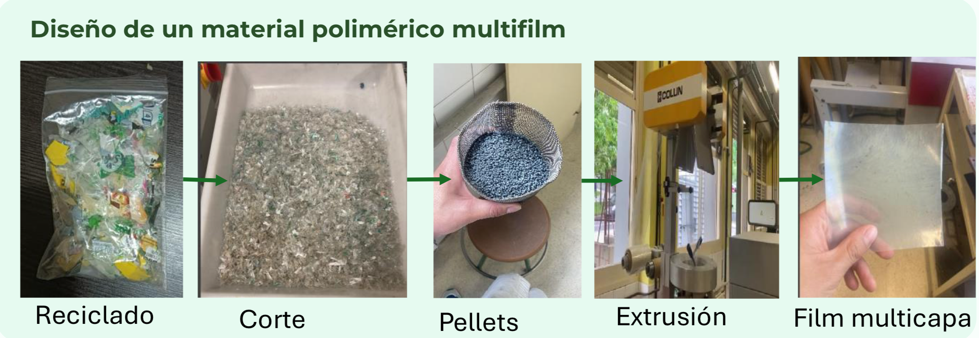Figure 1. Recycling and plastic treatment process as polymeric material for film production.

**Results**

Within the obtained results, different polymer blends of both PE and PP were made in various concentrations, both in the perpendicular direction to this, determining which have the best tensile properties of the material. Additionally, thermal transitions of each of the blends were analyzed using DSC, confirming that they correspond to the information reported in the literature. Moreover, different melt flow index tests were conducted to verify and introduce the optimal variable for its manufacturing into the experimentation. In terms of their barrier properties, PP provides a good barrier to gases and chemical resistance, while polyethylene stands out for its excellent moisture barrier and flexibility.

**Conclusions**

The use of techniques such as compression molding of polymer films obtained through Bowl Film using recycled materials is presented as a viable alternative in various sectors. This method takes advantage of the combination with commercial polymers like polypropylene (PP) for its barrier properties and polyethylene (PE) for its compatibility and mechanical strength.

**Acknowledgments:** To the Polymat Center for providing equipment and materials.

**References:**

[1] M. Seier, V. M. Archodoulaki, T. Koch, B. Duscher, and M. Gahleitner, “Prospects for Recyclable Multilayer Packaging: A Case Study,” *Polymers (Basel).*, vol. 15, no. 13, 2023, doi: 10.3390/polym15132966.

[2] V. Lahtela, S. Silwal, and T. Kärki, “Re-processing of multilayer plastic materials as a part of the recycling process: The features of processed multilayer materials,” *Polymers (Basel).*, vol. 12, no. 11, pp. 1–10, 2020, doi: 10.3390/polym12112517.

[3] I. Jönkkäri, V. Poliakova, V. Mylläri, R. Anderson, M. Andersson, and J. Vuorinen, “Compounding and characterization of recycled multilayer plastic films,” *J. Appl. Polym. Sci.*, vol. 137, no. 37, 2020, doi: 10.1002/app.49101.