Development of New Polymers Using Thiol-Based Monomeric Photoinitiators

Aniele de Moura ª*, Caroline Gaglieri ^{b}, Gabriel Iago dos Santos ^{b},
Gilbert Bannach ^{b}, Éder Tadeu Gomes Cavalheiro ª

ª (USP) University of São Paulo, São Carlos Institute of Chemistry, São Carlos-SP, Brazil
^{b} (UNESP) São Paulo State University, School of Sciences, Chemistry Department, Bauru-SP, Brazil
Email: aniele.apm@gmail.com*

A remarkable emerging area in photopolymerization focuses on the development and use of monomeric photoinitiators (MPI) and polymeric photoinitiators (PPI). These initiators can generate reactive species under light activation, promoted on chromophore groups in their structures. MPI have attracted significant attention because these compounds besides their ability to initiate polymerization, can also participate on it. This dual functionality allows a reduction in the amount of external photoinitiators (PI) to be used in photopolymerization, which considering the Green Chemistry Principles, is a positive point. Additionally, their use also offers other key advantages, such as: reduced polymer toxicity, minimized issues with PI miscibility in the monomer mixture and a decreasing of odors from residual PI degradation. In this study, thiol-based compounds were used as MPI (MPI-I and MPI-II). In addition, colorless polymers were obtained when MPI-I and MPI-II were reacted with acrylic acid (57% m/m) and triallyl isocyanurate (43% m/m) and exposed to UV light. These polymers exhibited enhanced thermal properties (Figure 1a and 1b) and mechanical properties than their reactants. Moreover, by adjusting the MPI content, shape-memory polymers were achieved.
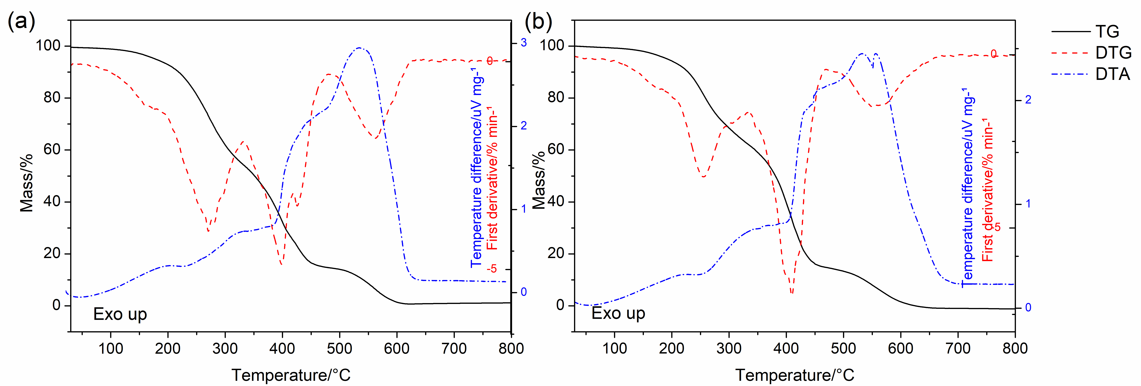

Figure 1. TG/DTG-DTA curves of the resulting polymers by using monomeric photoinitiator based thiols: MPI-I (a) and MPI-II (b).

Acknowledgments: The authors wish to thank São Paulo Research Foundation for the financial support (grant 2023/14645-5, 24/00779-2, 22/15211-6, and 22/03489-0).

References
[1] Avci, Duygu; Eren, Tugce Nur. Monomeric and Polymeric Photoinitiators. Chapter 4, 131 - 155
[2] Cinar, Sesil Agopcan, et al. Structure-reactivity relationships of novel monomeric photoinitiators, Journal of Photochemistry and Photobiology A: Chemistry, 329, 77-87, (2016).
[3] Cesur, Belgium, et al. Difunctional monomeric and polymeric photoinitiators: Synthesis and photoinitiating behaviors. Progress in Organic Coatings, 86, 71-78 (2015).

