**Rheological evaluation of polymer anisotropy using a novel technique**

F. David Santillana,b, Daniel A. Vegac,d, Marcelo A. Villara,b

a *Planta Piloto de Ingeniería Química, PLAPIQUI (UNS-CONICET), Bahía Blanca, Argentina*

*b Departamento de Ingeniería Química, Universidad Nacional del Sur, Bahía Blanca, Argentina*

*c Departamento de Física, Universidad Nacional del Sur (UNS), Bahía Blanca, Argentina.*

*d Instituto de Física del Sur, IFISUR (UNS-CONICET), Bahía Blanca, Argentina*

*Email:* [*fsantillan@plapiqui.edu.ar*](mailto:fsantillan@plapiqui.edu.ar)

In this study, we explore a novel technique that require fewer material and allows for rheological characterization of anisotropic polymer films in a simpler way than conventional forms [1]. Results of oscillatory shear rheometry, using parallel plates of 25 mm and disk-shaped samples, are compared using a new approach of different geometric arrays (hexagonal, pentagonal, and double triangular) of square-cut samples. As reference isotropic polymer films were used and then anisotropic films were characterized measuring the dynamic modules in two perpendicular directions of the sample with the best configuration achieved. Samples of block copolymers (SBS) were analyzed: isotropic films prepared using solution casting and anisotropic films obtained by roll-casting [2]. The storage modulus (G') and loss modulus (G'') were obtained in a rotational rheometer AR-G2 of TA Instruments in two perpendicular directions through the samples. The anisotropy of the samples was confirmed through tensile test using a universal test machine Instron 3369. Results indicate that an hexagonal array provides the most adequate values, closely resembling those obtained from the conventional disk method with some dependency in the samples thickness [3]. The anisotropy of the films was accused by their storage modulus (G’). Additionally, a correlation between G’ and Young modulus (E) was found. This novel method offers an alternative for characterizing the anisotropy of polymeric films.

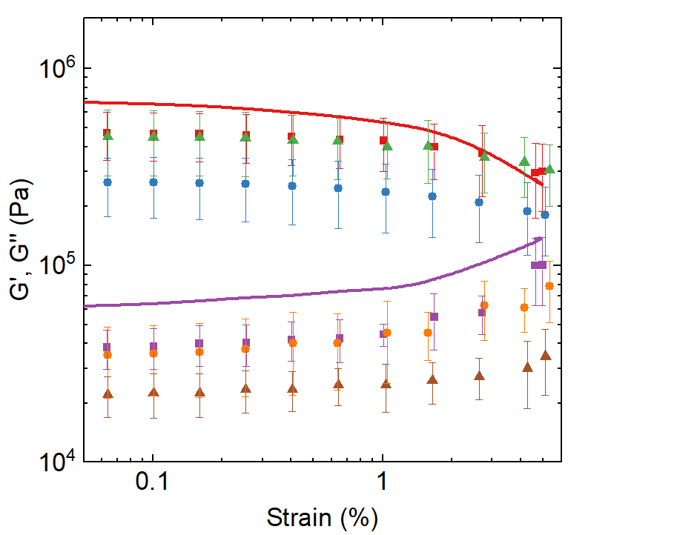

Disk

Hex.

Pent

Dtri

Figure 1. Storage(G') and loss (G'') modulus of samples as a function of strain. Geometry of disks and geometric arrangements studied. Symbols: (▬) G’. Disk, (■) G’.Hex., (●) G’. Dtri., (▲) G’. Pent., (▬) G’’. Disc, (■) G’.Hex., (●) G’. Dtri., (▲) G’. Pent.

Acknowledgments

Authors wish to thank the Universidad Nacional del Sur, UNS (PGI 24/M177), Consejo Nacional de Investigaciones Científicas y Técnicas, CONICET (PIP 102355), and Agencia Nacional de Promoción de la Investigación, el Desarrollo Tecnológico y la Innovación, Agencia I+D+i (PICT 2021-1175) for financial support.

References

[1] Volkov, V. S. & Kulichikhin, V. G. On the basic laws of anisotropic viscoelasticity. Rheol Acta 46, 1131–1138 (2007).

[2] Villar, M. A., Rueda, D. R., Ania, F. & Thomas, E. L. Study of oriented block copolymers films obtained by roll-casting. Polymer 43, 5139–5145 (2002).

[3] Polushkin, E., Alberda van Ekenstein, G., Ikkala, O. & ten Brinke, G. A modified rheometer for in-situ radial and tangential SAXS studies on shear-induced alignment. Rheol Acta 43, 364–372 (2004).