Promising routes for transforming PET waste into functional polymers
Daniele Juliana Caffeuª, Gabriel I. dos Santosª, Rafael T. Alarcon^{b}, Aniele de Moura,ª Fernanda B. dos Santos,ª Gilbert Bannachª, Caroline Gaglieriª

ª São Paulo State University (UNESP), School of Sciences, Bauru, SP 17033-360, Brazil
^{b}Instituto de Química de São Carlos, Universidade de São Paulo-USP, São Carlos, SP 13566-590, Brazil
Email: caroline.gaglieri@unesp.br
Polyethylene terephthalate (PET) is one of the most polymer used in the word, being used in different fields: packaging, houseware, gardening and so on. As a result, 2.9 Mt of PET was global produced only in 2022.¹ This, associated with the low content of post-consumer mechanically recyclability of polymers (12.9%),¹ demanding new solutions for PET: the chemical recyclability. Therefore, this work shows two distinctive routes to recovering the wasted PET reacting it with glycerol (also a by-product from biodiesel production): heating assisted by microwave irradiation (PET-MO) and conventional heating (PET-CH). Both methods resulted in white solids, which were easily triturated. The TG/DTG-DTA curves of polymers are present in Figures 1a-1c. PET was thermal stable until 350 ºC, while PET-MO and PET-CH up to 135 ºC and 139 ºC, respectively. However, this first mass loss present in modified PETs can be associated with residual glycerol. The main chain degradation initiated at 260 ºC (PET-MO) and 265 ºC (PET-CH). In addition, DTA curves of modified PETs were very similar to each other; however, they changed compared to the PET. These PET-based powders were tested as filters to remove Rhodamine B from water (initially 10 ppm, measured by UV-Vis). As observed in Figure 1d, the filter was able to be used 13x without recovering and still removed more than 90% of dye. As a result, both processes tested provided a new PET-based polymer, which can be powdered and present distinct properties from PET (suggesting a chemical modification), such as dyes adsorption. Corroborates therefore with the circular economy and with the SDG (Sustainable Development Goals), especially with 9 and 12.
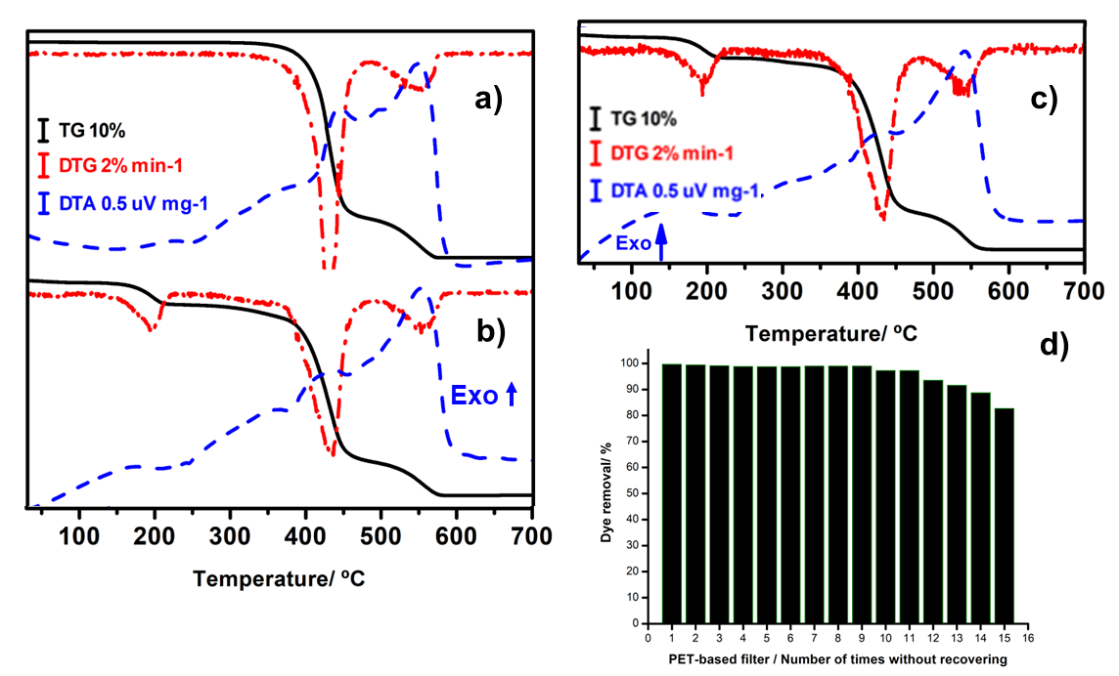
Figure 1. TG/DTG-DTA curves of a) PET, b) PET-MO, c) PET-CH and d) Removal percentage of Rhodamine B from water solution testing PET-MO as a filter.

Acknowledgment: The authors wish to thank São Paulo Research Foundation - FAPESP (grants 2024/00779-2, 2021/14879-0; 2022/15211-6, 2023/14645-5, 2022/03489-0, 2024/02562-0) and National Council for Scientific and Technological Development-CNPq (grant 303247/2021-5) for financial support.
References
[1] PLASTIC EUROPE. Plastic the Facts 2023. https://plasticseurope.org/knowledge-hub/plastics-the-fast-facts-2023/. Accessed in 22 set 2024.

