Electrospun scaffolds based on a PCL/starch reinforced with bioglass nanoparticles for bone tissue engineering

Marcela Saavedraª, Deborah Cordovaª, Viviana Moreno-Serna^{b}, Alexander Cordobaª, Felipe Gutiérrezª, Daniel Canalesª, Carlos David Grande-Tovar^{c}, Paula A. Zapata^{a*}

ª Universidad de Santiago de Chile, Facultad de Química y Biología, Departamento de Ciencias del Ambiente, Grupo Polímeros, Santiago, Chile
^{b} Universidad Arturo Prat, Facultad de Ciencias de la Salud, Laboratorio de Química Medicinal, Iquique, Chile
^{c} Universidad del Atlántico, Grupo de Investigación en Fotoquímica y Fotobiología, Puerto Colombia, Colombia
Email: paula.zapata@usach.cl

In this study, bioactive fibers were produced by electrospinning by incorporating 5% by weight of bioglass (BG) nanoparticles in a PCL/starch solution. The morphological, water retention, degradation, thermal and mechanical properties, as well as the in vitro bioactivity of the nanofibers were investigated and discussed. The fibers were homogeneously deposited with diameters between 311 and 438 nm. The results showed an increase in water absorption capacity (ca. 1700% in 24 h) and a higher degradation rate (37% weight loss) [1]. Thermal analysis revealed that starch increased crystallinity by 9%, while BG reduced it by 7%. An intermediate effect was observed in the PCL/starch/BG scaffold, partially compensating for the BG disruption. There was a decrease in Young's modulus and tensile strength (60% and 52%, respectively), but a 20% increase in elongation at break compared to pure PCL. In addition, PCL/Starch/BG scaffolds showed enhanced in vitro biomineralization capacity after 14 days and improved cell adhesion and viability in MG-63 osteoblastic cell lines. After 60 days of subdermal implantation in Wistar rats, PCL/Starch/BG fibers demonstrated superior biocompatibility and improved resorption process. In conclusion, the developed PCL/Almidon/BG electrospun scaffolds present bioactive, biocompatible and bioabsorbable characteristics, with potential for use in bone tissue engineering.
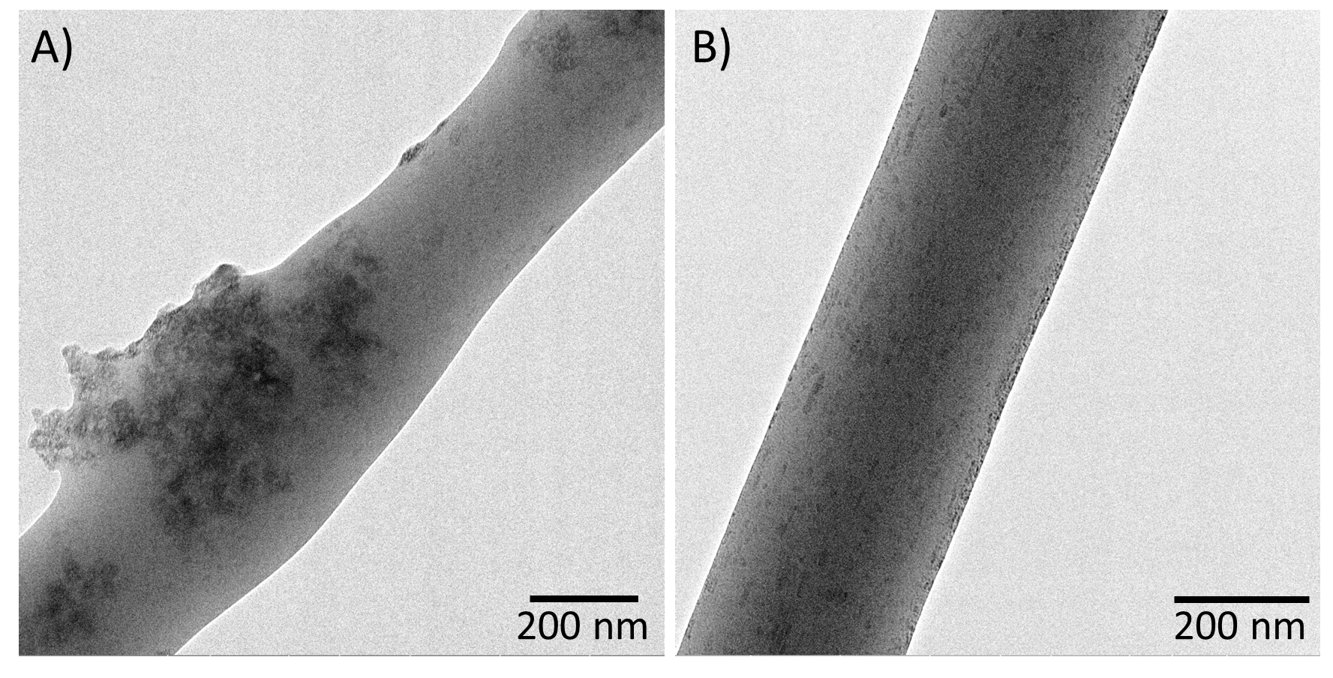
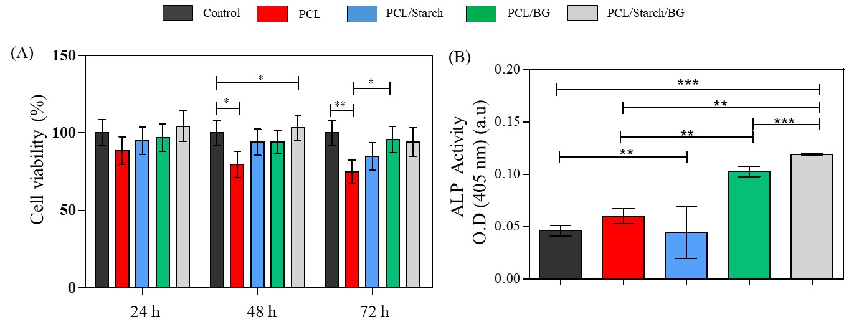
PCL/BG
b)
c)
PCL/Starch/BG
a)

Figure 1. a) TEM images of electrospun fibers directly onto the TEM grid, b) cell viability, after 24, 48 and 72 hours of exposure, and c) alkaline phosphatase (ALP) activity cultured in osteogenic medium for 7 days, both assays for PCL, PCL/starch, PCL/BG and PCL/starch/BG scaffolds using an MG-63 cell line.

Agradecimientos:
Los autores agradecen al proyecto Proyecto FONDECYT Regular 1220093.

Referencias:
[1] García G., et al, Electrospun scaffolds based on a PCL/starch blend reinforced with CaO nanoparticles for bone tissue engineering, Int. J. Biol. Macromol, 273, 132891 (2024)

