Amino acids as bio-organocatalysts in ring-opening copolymerization for eco-friendly synthesis of biobased oligomers from vegetable oils

Francisca Werlinger,^{a,b} Monserrat Beroíza-Duhart,^{b} Oscar A. Douglas-Gallardo,^{b} Oleksandra S. Trofymchuk,ª Mario E. Flores^{b} and Javier Martínez^{b}

ª Facultad de Ciencias Químicas y Farmacéuticas, Departamento de Química Orgánica y Fisicoquímica, Universidad de Chile, Santiago 8380492, Chile
^{b} Instituto de Ciencias Químicas, Facultad de Ciencias, Isla Teja, Universidad Austral de Chile, Valdivia 5090000, Chile.
Email: f.werlinger@gmail.com

The widespread usage of petroleum-based products and the need to reduce reliance on them in many human activities is a global concern in the 21st century. Therefore, sustainable development should be the focal point in future investigations. In this regard, it is necessary to develop novel chemical products and design environmentally friendly synthetic routes [1]. Herein, we present an innovative synthetic approach for producing diverse biobased oligomers. This method employs a wide variety of commercially available amino acids (AAs) as bio-organocatalysts and tetrabutylammonium iodide (TBAI) as a cocatalyst (Figure 1).
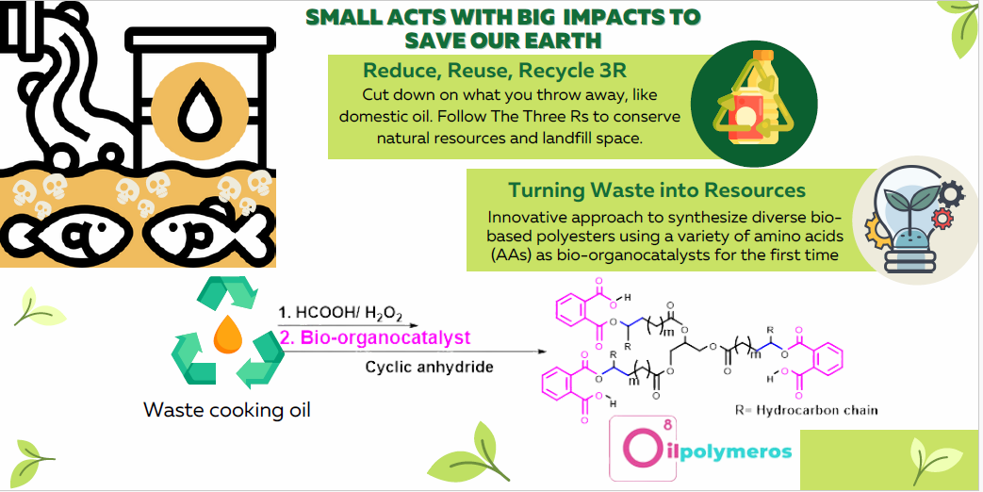
Figure 1. Amino acids used as bio-organocatalysts to prepare biopolyesters from waste cooking oils.

These biobased oligomers were strategically prepared starting from epoxidized olive oil (EOO) and a variety of cyclic anhydrides (phthalic, PA; maleic, MA; succinic, SA; and glutaric, GA). This oligomers were characterized using techniques including NMR, FT-IR, GPC and TGA. A series of computational simulations based on density functional theory (DFT) and post-Hartree Fock (post-HF) methods were performed to corroborate our experimental findings [2].

Agradecimientos:
Los autores agradecen a los proyectos FONDECYT 3220023, 1220241, 11230124 and FOVI230027.

Referencias:
[1] A. J. Kamphuis, F. Picchioni, P. P. Pescarmona, CO₂-fixation into cyclic and polymeric carbonates: principles and applications. Green Chem., 21, 406–448 (2019).
[2] F. Werlinger, M. Beroíza-Duhart, O. A. Douglas-Gallardo, S. Oyarzo-Aro, M. L. Valenzuela, O. S. Trofymchuk, M. E. Flores, J. Martínez, Amino acids as bio-organocatalysts in ring-opening copolymerization for eco-friendly synthesis of biobased oligomers from vegetable oils. Org. Biomol. Chem., 22, 4135-4144 (2024).

