Biodegradable Microparticles from Poly(butylene succinate) and Tartaric Acid

Luciana Dutraª, Martina Pintoª, Rafael Coelho^{b}, Leticia Miranda^{b}, José Carlos Pintoª

ª Federal University of Rio de Janeiro, Chemical Engineering Program (PEQ/COPPE), Rio de Janeiro, RJ, Brazil
^{b} Federal University of Rio de Janeiro, Chemical School (EQ), Rio de Janeiro, RJ, Brazil
Email: ldutra@eq.ufrj.br

The increasing demand for eco-friendly alternatives has intensified the search for sustainable and biodegradable polymeric materials. Among these, poly(butylene succinate) (PBS) and its copolymers stand out due to their favorable mechanical and thermal properties, as well as their renewable origin. The inclusion of tartaric acid in the PBS chain improves thermal, mechanical, and degradability properties, broadening its industrial applications [1]. In this study, biodegradable microparticles were produced by suspension polycondensation [2], using different concentrations of tartaric acid (2.5%, 5%, 10%, and 25%) to create hydrophilic particles that are potentially branched or crosslinked. The microparticles obtained ranged in size from 181 to 471 µm, as shown in Figure 1B. The analysis of molar masses (Figure 1A) indicated that the polymer produced with tartaric acid and 1,4-butanediol (PBTA) was not soluble in chloroform, suggesting crosslinking, evidenced by the narrowing of the molar mass distribution as the tartaric acid load increased. The reduced solubility in chloroform may have limited the analysis to the soluble fraction. The introduction of tartaric acid promotes the formation of branched chains and increases the hydrophilicity level of the obtained matrices. For instance, with tartaric acid concentrations above 10%, there was a 13% reduction in contact angle, suggesting greater hydrophilicity. Despite the water affinity, the particles did not show significant swollen behavior, even with the incorporation of the copolymer. These results demonstrate the potential of PBS microparticles copolymerized with tartaric acid for industrial applications.

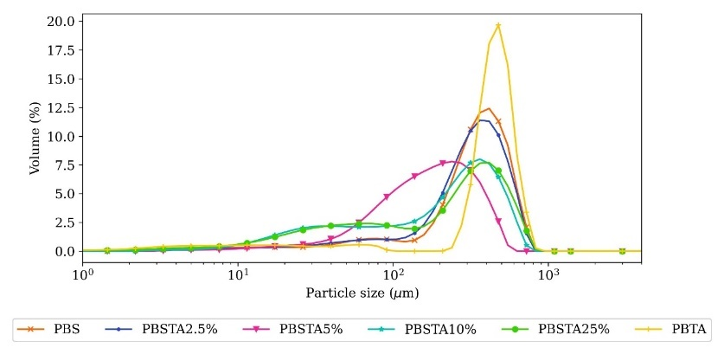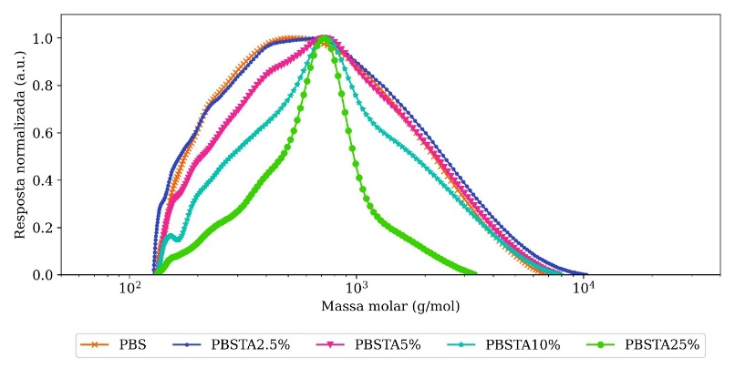
Figure 1 – Particle size (A) and Molar mass (B) distributions of biodegradable microparticles produced with different concentrations of tartaric acid.

Acknowledgments:
The authors thank FAPERJ (project numbers E-26/204.566/2021, E-26/204.567/2021, and E-26/202.251/2018), CNPq, and CAPES for the financial support.

References:
[1] Zakharova, E., Lavilla, C., Alla, A., Martínez De Ilarduya, A., & Muñoz-Guerra, S. Modification of properties of poly(butylene succinate) by copolymerization with tartaric acid-based monomers. European Polymer Journal, 61, 263–273, (2014).
[2] Dutra, L., Nele, M., & Pinto, J. C. A Novel Approach for the Preparation of Poly(Butylene Succinate) Microparticles. Macromolecular Symposia, 381(1), 1800118, (2018).

