**Enzymatic degradation of high recalcitrant polymeric structures**

Javier Aguileraa, Rodrigo Andlera

a *School of Biotechnology Engineering, Bioprocess Laboratory, Universidad Católica del Maule, Talca, Chile*

*Email:* [*javier.aguilera@alu.ucm.cl*](mailto:javier.aguilera@alu.ucm.cl)

The overproduction of synthetic polymers, such as polystyrene and vulcanized rubber (e.g., tires), has become a significant environmental concern. In 2023, an estimated of 410 million tons of plastics and 14.6 metric tons of rubber were produced, with a substantial amount ending up in landfills where they persist for centuries [1]. To address this issue, we propose an enzymatic upcycling strategy to convert polymeric waste into valuable oligomers [2].

Our approach involves the heterologous production of laccases and peroxidases from *Rhodococcus ruber*. These enzymes were produced in competent *Escherichia coli* cells using an autoinduction media culture system [3]. Plasmids containing the enzyme genes were introduced into the bacteria through heat-shock transformation, followed by antibiotic selection. The bacterial cultures were then grown in bioreactors and lysed using an ultrasonic stirrer to release the enzymes. Purification was achieved using a strep-tactinXT gravity flow affinity column, and the purity of the enzymes was confirmed by sodium dodecyl sulfate-polyacrylamide gel electrophoresis (SDS-PAGE).

Initial application studies demonstrated the ability of these enzymes to degrade both polystyrene and a tire-like elastomer. Fourier Transform Infrared Spectroscopy (FTIR) analysis suggested the formation of novel organic compounds within the polymeric structures, indicating successful enzymatic catalysis. This promising result paves the way for further in-depth investigations into the potential of enzymatic upcycling for sustainable polymer management.

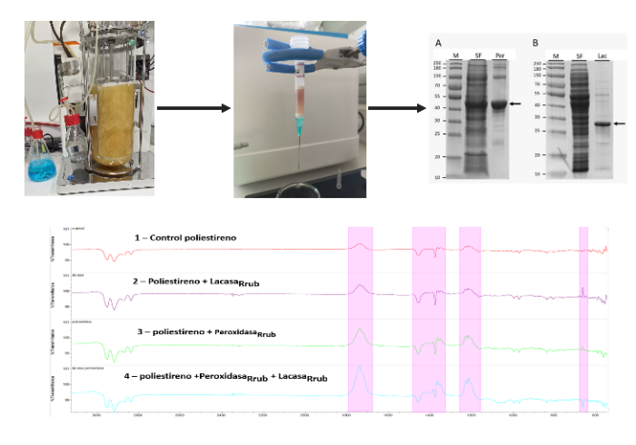

Figure 1. Methodology of production and purification of enzymes and FTIR analysis of polystyrene degradation.

Agradecimientos:

Autors thanks to the fondecyt N° 1230313 and the Bioproceses Laboratory of Universidad Católica del Maule.

Referencias:[1] Jagadale S, Rajkumar K, Chavan R et al, Indian Rubber Manufacturers Research Association, International Journal of Research in Engineering and Technology, 04, 1-6 (2014)

[2] Andler R, Bacterial and enzymatic degradation of poly(cis-1,4-isoprene) rubber: Novel biotechnological applications, Biotechnology Advances, 44, (2020)

[3] Studier, Protein production by auto-induction in high-density shaking cultures, Protein Expression and Purification, 41, 207-234 (2005)