Renewable self-blowing poly-imide foam from vegetable oils and isocyanate

Luciano C.R. Raisª, Jonatha de Freitasª, Francisco V.B. Nascimentoª, Aniele de Mouraª, Rafael T. Alarconª, Éder T.G. Cavalheiro^{a*}

ªUniversidade de São Paulo-USP, Instituto de Química de São Carlos, São Carlos, SP, Brazil.
*Email: cavalheiro@iqsc.usp.br

Polymeric material foams have been used for technological proposes such as acoustic materials, flame retardants, filters, wound healing, adhesives, coating, and so forth. However, most of these foams depend on a reaction between a polyol with an isocyanate compound and blowing agents (e.g. water, sodium carbonate and organic solvents). To avoid excess reactants and improve the reaction velocity, it is necessary to use compounds that fast react releasing small molecules, which permits the blowing process. In this sense, a novel synthetic route was designed to use renewable monomers as a principal blowing agent. Therefore, maleinized vegetable oil reacted with methylene diphenyl diisocyanate – MDI to release CO₂ and form renewable foams containing imide units – Figure 1-a [1]. However, these foams presented a fragile mechanical property, then, to overcome this issue, the castor oil was added to the synthetic mixture, which formed urethane units improving mechanical properties. These foams are exhibited in Figure 1-b. The MIR spectrum for polyurethane-amide (Figure 1-c) display the vanishing of N=C=O stretching at 2264 cm⁻¹, and as consequence of one new band appeared at 1704 cm⁻¹ which is associated with C=O stretching of urethane and imide units.
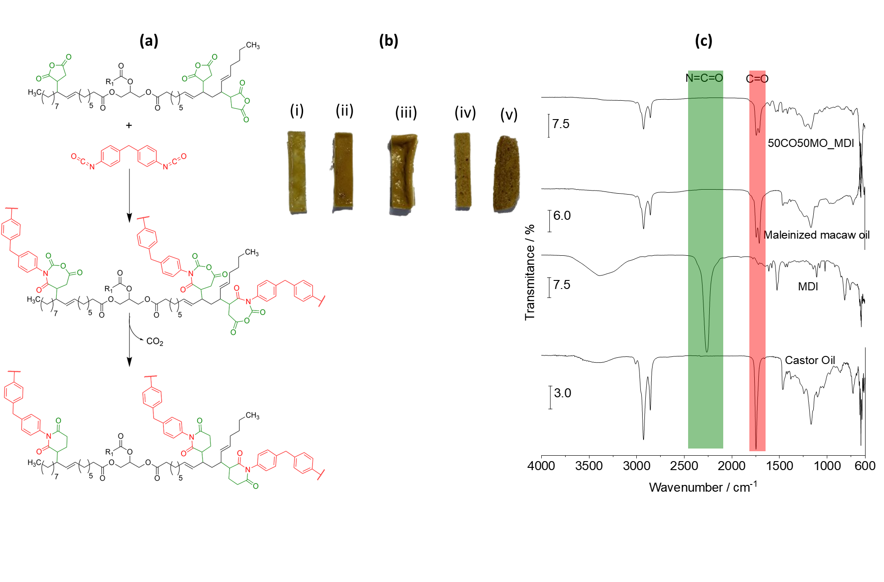
Figura 1. (a) Poly-imide reaction, (b) foam images (i) 100% CO – 0%MMO – MDI, (ii) 80% CO – 20%MMO -MDI, (iii) 50% CO – 50% MMO – MDI, (iv) 20%CO – 80 MMO – MDI, (v) 0%CO – 100%MMO - MDI (c) MIR spectra.

Acknowledgements:
The authors wish to thank the São Paulo Research Foundation–FAPESP (grant 2023/15889-5, 2023/14645-5, 2022/15211-6, and 2021/14879-0) and the National Council for Scientific and Technological Development-CNPq for financial support.

References:
[1] Guo Y., Spicher S., Cristadoro A., Deglmann P., Sijbesma R.P., Tomovic Z. Towards high-performance polyurethanes: a mechanism of amine catalyzed aromatic imide formation from the reaction of isocyanates with anhydrides. Polymer Chemistry. 14, 1773-1780, 2023

