Green Flexible Composite Electrode Using Renewable Materials

Jonatha de Freitasª, Rafael da Silvaª, Rafael T Alarconª, Éder TG Cavalheiro^{a*}

Universidade de São Paulo - USP, Instituto de Química de São Carlos, São Carlos, SP, Brazil.
*Email: cavalheiro@iqsc.usp.br

Weareble flexible electrodes have showed significant interest in the field of skin and mucosal interface sensing, enabling long-term multimodal monitoring of mechanical, electrochemical, electrophysiological signals, and continuous ultrasound imaging [1]. Despite the success of existing flexible electronics, they still present limitations due to the predominant composition of polymeric elastomers and rigid electronic components [2]. This research aims to develop flexible composite electrodes using graphite and polymers derived from castor oil, a renewable resource abundant in Brazil [3]. Thermal and mechanical properties of polymer samples were investigated using DMA. Surface properties were evaluated through contact angle measurements. Biobased content (BC) and biobased carbon content (BCC) were calculated, and solvent resistance and hydrolysis were tested qualitatively over 24 hours.
The polymer exhibited properties such as being colorless and flexible (Fig. 1a), although it lacks high stress resistance (Fig 1b). Additionally, the glass transition temperature was observed at -11.6 ºC (Fig. 1c). The polymer also demonstrated a biobased content and biobased carbon content of 100%, underscoring its sustainability and greener renewable."

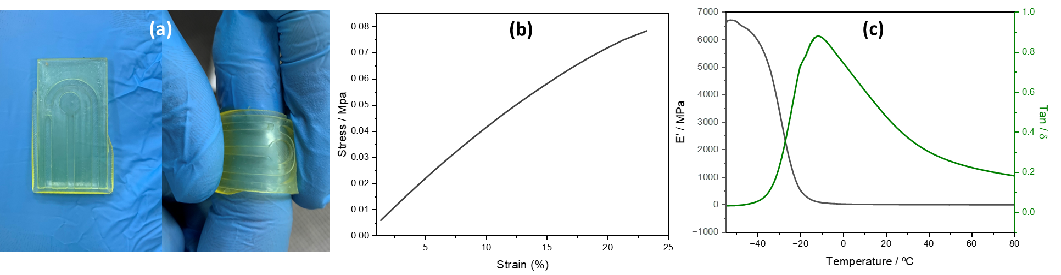
Figura 1. (a) polymer, (b) DMA curves stress – strain and (c)| modulus storage – (E´, black line) and tan-δ (green line);

Achnowledgment
The authors wish to thank the São Paulo Research Foundation–FAPESP (grant 2023/15889-5, 2023/14645-5, 2022/15211-6, and 2021/14879-0) and the National Council for Scientific and Technological Development-CNPq for financial support.

Referencias:
[1] Nan, K.; Feig, V. R.; Ying, B.; Howarth, J. G.; Kang, Z.; Yang, Y.; Traverso, G.
Mucosa-interfacing electronics. Nat. Rev. Mater. 7, 908−925, 2022.
[2] Murray, R. W. Techniques of Chemistry: Molecular Design of Electrode Surfaces. Wiley- Interscience: New York, p. 448, 1992.
[3] Rios ÍC, Cordeiro JP, Arruda TBMG, Rodrigues FEA, Uchoa AFJ, Luna FMT, et al. Chemical modification of castor oil fatty acids (Ricinus communis) for biolubricant applications: An alternative for Brazil’s green market. Industrial Crops and Products 2020

