Enhancing UV printer ink adhesion onto aeronautical polyurethane coating surface via atmospheric plasma treatment
Lília Muller Guerriniª, Maria Augusta Saemi Yokomichiª, ª, Celso Molina^{b}, Hermes Neves da Costa^{b}, Victor H. F Salesª, Rogério Scafutto Scottonª, Mauricio Pinheiro Oliveiraª

ª Federal University of São Paulo, ICT, São José dos Campos, São Paulo, Brazil
^{b} Federal University of São Paulo, ICAQF, Diadema, São Paulo, Brazil
guerrini@unifesp.br

The use of UV digital inkjet printing in aerospace industry has received significant attention in recent years due to its ability to produce complex logos, lettering, and images directly on the airplane fuselage, with the possibility of reduced operating costs such as time and amount of the paint. Furthermore, the application of UV digital inkjet printing onto aeronautical polyurethane (PU) results in poor printing quality, and adhesion ^{[1]}. In this work, aeronautical PU coating surface was treated by cold plasma to improve the UV printer ink adhesion ^{[2]}. The plasma power applied varied from 600 to 850 W, the speeds for treatments used were 17 and 35 mm/s, and the distance was fixed at 4 mm. Two gases were performed for plasma activation: air and nitrogen (N₂). The surface of untreated and treated PU was evaluated by free surface energy, and chemical structure (FT-IR). The adhesion of digital printed PU was studied by cross-hatch and pull-off tests. No significant change was found in the chemical surface structure by infrared analysis. Free surface energy of these samples after treatment increased from 51 mN/m to values between 68 and 75 mN/m (Fig. 1). The samples presented better ink adhesion (Fig. 2) after plasma treatment.This study created a new insight about plasma treatment for improvement of the adhesion between digital ink and aeronautical PU coating.
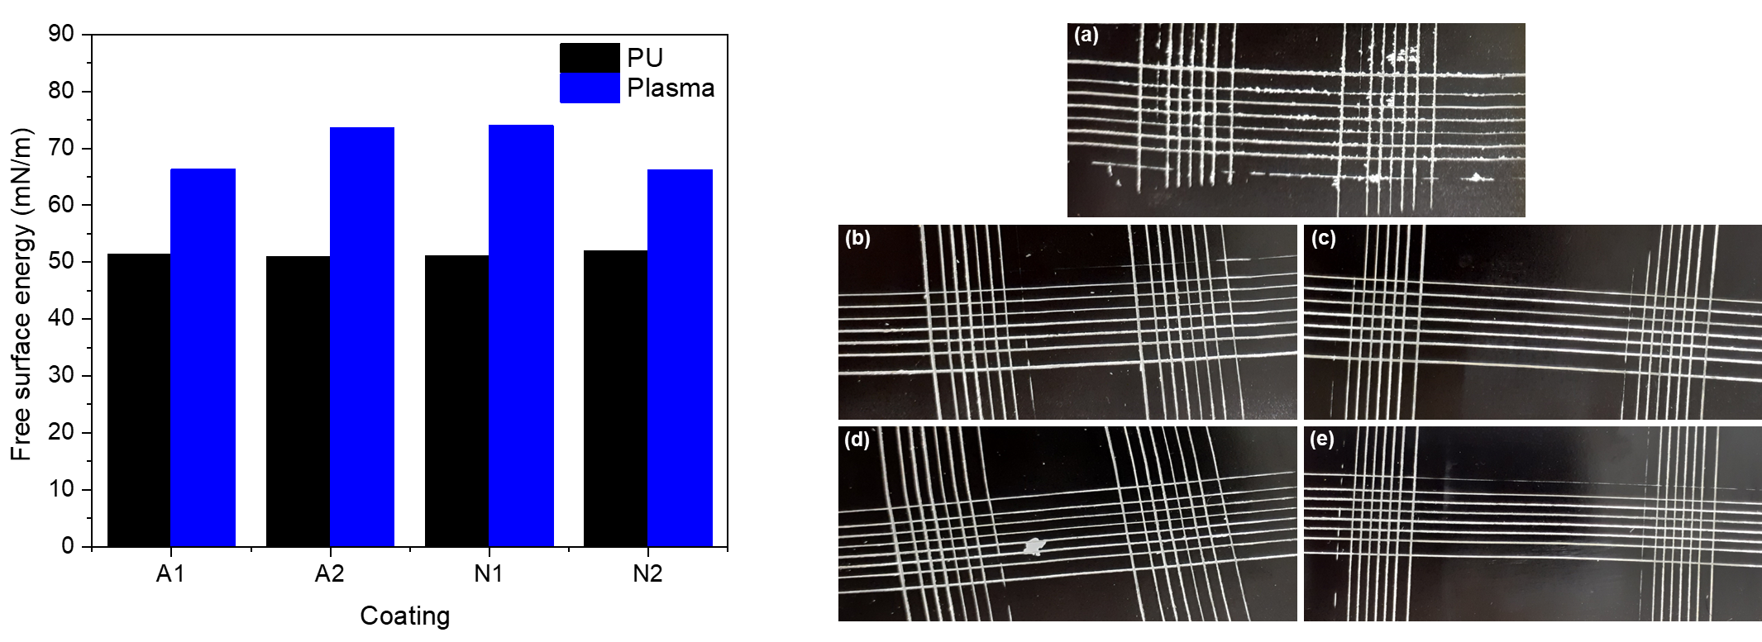
Figure 2. Cross-hatch results of the printed samples:
(a) without treatment, (b) A1 (c) A2 (d) N1, and (e) N2.
Figure 1. Free surface of energy of PU coatings:
A1 (air, 17 mm/s, 850 W), A2 (air, 35 mm/s, 600W)
N1 (N₂, 17 mm/s, 850W) and N2 (N₂, 35 mm/s, 850W)
.

Acknowledgments:
The authors acknowledge the financial support of the National Council for Scientific and Technological Development, grant 03559/2023-3, and São Paulo Research Foundation (FAPESP), 2021/07970-1.

References:
[1] SCOTTON, R. S.; GUERRINI, L. M.; OLIVEIRA, M. P. Progress in Organic Coatings, 158, 106389, 2021.
[2] Levchenko I., Xu S., Baranov O. , Bazaka O., Ivanova E. P., Bazaka K. Plasma and Polymers: Recent Progress and Trends, Molecules, 26, 4091, 2021.

