Effect of carbon nanotube incorporation in electrospun cellulose acetate membranes

Ana Rita Moralesª, Jéssica Silva Pereiraª
ª Universidade Estadual de Campinas (UNICAMP), Faculdade de Engenharia Química, Campinas, Brasil
Email: morales@unicamp.br

INTRODUCTION
Cellulose acetate (CA) is a biodegradable polymer with high chemical and mechanical resistance and its membranes are highly versatile and can be used in water treatment systems, gas separation, and energy generation¹. Electrospinning is a simple technique that has been reported for CA membranes fabrication. The fibers can have different geometries² where it is possible to incorporate nanoparticles like carbon nanotubes (CNT)³. CNT is a carbonaceous filler of graphene sheets, which has excellent electrical, chemical, and mechanical properties³. There are few studies exploring the effect of incorporating CNT into CA nanofibers so, this work investigated the incorporation of CNT on CA electrospun membranes.

EXPERIMENTAL and RESULTS
The membranes were produced by electrospinning with the parameters: 18 kV of voltage, 15 mL/h of flow rate, and 10 cm of distance to collector plate. The precursor solution was composed of 16% (w/w) of CA (Mn~30,000 g/mol; Sigma-Aldrich Brasil Ltda) dissolved in an 85% (w/w) aqueous solution of acetone with 0.5% and 1% (w/w) of MWCNTs-OH (diameter: 8~15 nm; Interprise USA Corporation). The membranes morphology was analyzed by scanning electron microscope (SEM), and hydrophobicity was quantified by measuring contact angle between the surface and the water droplet.
The electrospun membranes had a porous structure with randomly oriented nanofibers (Fig.1a). The incorporation of CNT modified the geometry of the CA nanofibers, whose diameter increased with the increase of nanofiller concentration (Fig.1b-d). It is observed some roughness on the surface of the nanofibers with CNT. CA is a hygroscopic material but, according to ASTM D7334-08, the nanofibers with CNT have a hydrophobic character, with a contact angle of over 90°, which is enhanced as the CNT concentration increases, as shown in Fig. 1e-f.

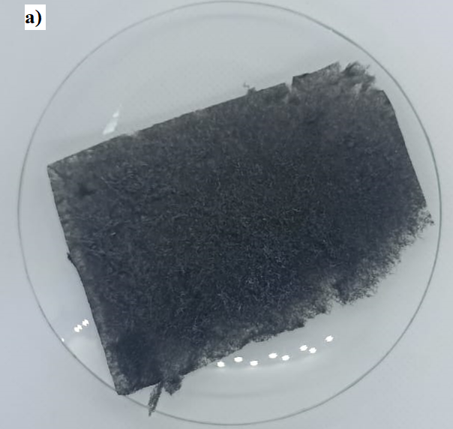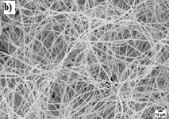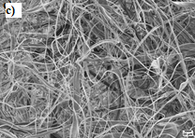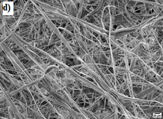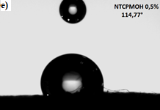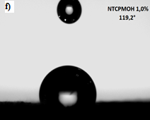
Figure 1: (a) CA +1% CNT membrane; SEM images of nanofibers: (b) CA: diameter 0.5-5 µm; (c) CA+0.5% CN: diameter 0.5-29 µm; (d) CA+0.5% CNT: diameter 0.5-29 µm; contact angle: (e) CA+0.5% CNT: 114.77°; CA+1.0% CNT: 119.2°.

ACKNOWLEDGMENTS
Thanks CAPES and School Chemistry Engineering – UNICAMP for support given to the research.

REFERENCES
1. V. Vantanpour et. al, Chemosphere. 295, 133914 (2022)
2. J. Xue et. al, Adv. Sci. 7, 2070083 (2020)
3. C. Xia et. al, Small Science. 1, 2100010 (2021)

