Stimulus Responsive Polymer-Liposome Complexes for Drug Delivery

Patrícia Alvesª

ª University of Coimbra, CERES, Department of Chemical Engineering, 3030-790 Coimbra, Portugal
Email: palves@eq.uc.pt

The attachment of functional polymers to liposomes through hydrophobic anchors has emerged as a strategy to prepare stimuli-responsive materials used as drug delivery systems. For this purpose, a polymer with an hydrophobic anchor (cholesterol) was prepared [1,2]. Poly(N,N-dimethylaminoethyl methacrylate) (PDMAEMA) was chosen due to its ability to respond to environmental changes in temperature and pH. PDMAEMA is an amphiphilic molecule composed of methacrylate, a substituent containing poly(2-ethylacrylic acid), responsible for temperature or pH changes [3]. Polymer-liposome complexes (PLCs) were prepared with lecithin and cholesterol-poly(N,N-dimethylaminoethyl methacrylate) (CHO-PDMAEMA) according to Figure 1.
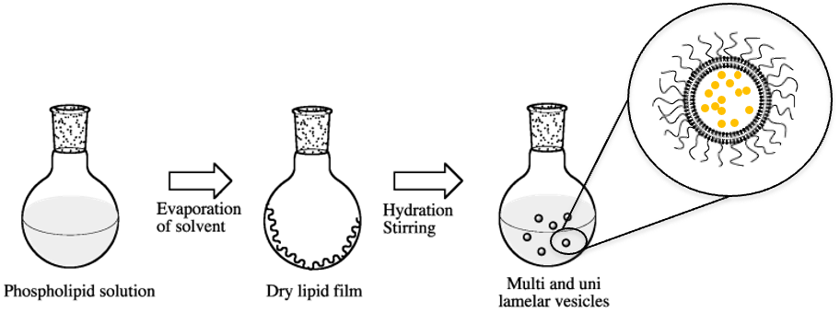
Figure 1. PLCs preparation

The stability of both bare liposomes and PLCs was evaluated at 37 °C and 42 ºC. In vitro studies assessed biocompatibility and incorporation of PLCs into the cells.
Three main characteristics were afforded by the presence of CHO-PDMAEMA in liposomes:
- stabilization at physiological temperature and neutral pH,
- increased uptake by phagocytic and non-phagocytic cells,
- release of content at 42 ºC.

Acknowledgments:
This research was funded by Strategic Research Center (CERES) Project UIDB/00102/2020 supported by FCT - Fundação para a Ciência e a Tecnologia I.P. And by national funds from FCT - Fundação para a Ciência e a Tecnologia, I.P., within the project 2022.02495.PTDC.

References:
[1] P. Alves, A.A. Hugo, E.E. Tymczyszyn, A.F. Ferreira, R. Fausto, P.F. Pérez, J.F.J. Coelho, P.N. Simões and A. Gómez-Zavaglia, Colloids Surfaces B, 104 (2013) 254–261.
[2] P. Alves, A.A. Hugo, F. Szymanowski, E.E. Tymczyszyn, P.F. Pérez, J.F.J. Coelho, P.N. Simões, A. Gómez-Zavaglia, Colloids Surfaces B, 123 (2014) 446-451, https://doi.org/10.1016/j.colsurfb.2014.09.043.
[3] M.G.Simões, A. Hugo,A. Gómez-Zavaglia, P.N. Simões, P. Alves, Pharmaceutics, 14 (2022) 735.

