Development of a colorimetric bacterial detection device for urinary infections
Marta Santos^{a,b}, Marcos Marizª, Igor Tiago^{c}, Susana Alarico^{d}, Paula Ferreira^{a,b,e,*}

ªUniversity of Coimbra, CERES, Coimbra, Portugal; ^{b}Polytechnic University of Coimbra, CERNAS, Coimbra, Portugal; ^{c}University of Coimbra, CFE, Coimbra, Portugal; ^{d}University of Coimbra, CNC and CIBB, Coimbra, Portugal; ^{e}Polytechnic University of Coimbra, i2A, Coimbra, Portugal
Email: paula.ferreira@ipc.pt

Urinary catheters play a crucial role in various medical situations, yet they also contribute significantly to urinary tract infections (UTI). Catheter-associated urinary tract infections (CAUTI) account for up to 80% of hospital-acquired infections, worsening patients' health and increasing hospital stays, costs, and mortality [1]. This work aims to tackle this problem by developing TimeUp, a point-of-care technology, that continuously monitors catheter urine, changing color to alert healthcare professionals of an early-stage UTI, improving treatment procedures, and avoiding unnecessary antibiotic administration.
The core of this device relies on glucose-based polyurethane (PU) foams, with characteristics such as porosity, water sorption capacity, capillarity, and reduced degradation. These foams were then functionalized with polyethyleneimine (PEI) using a phase inversion technique allowing posterior functionalization with the chromogenic substrate X-Glu. X-Glu specifically detects the activity of E. coli, which is responsible for about 80% of the UTI [2]. Experimental testing demonstrated the efficacy of the final matrices in detecting E. coli through a color change, in media with cell concentrations of 10⁸, 10^{5,} and 10² CFU/mL. In the medium with the highest concentration of cells, the matrices showed a change in color before 22 h of testing. After 42 h, all samples in contact with bacteria changed color.

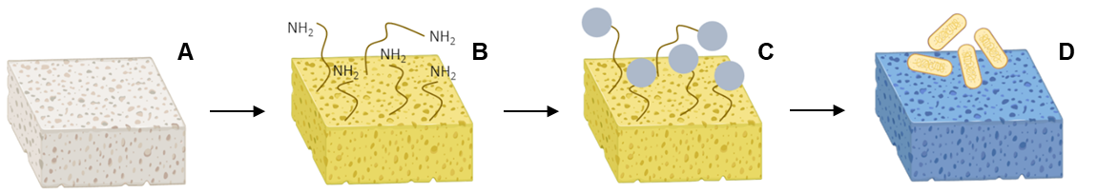

Figure 1. Procedure phases: A - PU foam; B - Functionalization with PEI; C - X-Glu Immobilization and D - Color change upon contact with E.coli.

Acknowledges:
The authors thank FCT for the PhD grant DFA/BA/5675/2020 (to M. Santos), and contracts SFRH/BPD/108299/2015 (to S. Alarico), and (CEECINST/00077/2021) (to P. Ferreira).
FCT, PORTUGAL 2020 through projects UIDB/00102/2020 (authors from CERES), UIDB/04539/2020, UIDP/04539/2020 and LA/P/0058/2020 (authors from CNC-UC) and UIDP/00681/2020 (authors from CERNAS). “La Caixa” Foundation, Barcelona, project referenced as CI19-0100 TimeUp.

References:
[1] K. Clarke, C.l. Hall, Z. Wiley, S.C. Tejedor, J.S. Kim, L. Reif, L. Witt, J.T. Jacob, Catheter-Associated Urinary Tract Infections in Adults: Diagnosis, Treatment, and Prevention, J. Hos. Med. 15, 552-556 (2020)
[2] S.D. Gür, M. Bakhshpour, A. Denizli, Selective detection of Escherichia coli caused UTIs with surface imprinted plasmonic nanoscale sensor, Mater. Sci. Eng. 104, 109869 (2019)

