Thermal behavior of injection cavity 3D printed

Pozza, P.S. ª; Machado, G. M.ª; Silva, V.H.Q.ª; Souza, E. M. O.ª; Berkenbrock, G.R.ª;
Scalice, R.K.ª; Sacchelli, C.M.ª; Pachekoski, W. M.ª

ª Universidade Federal de Santa Catarina, Centro Tecnológico de Joinville, Joinville, Brasil
Email: wagner.pachekoski@ufsc.br

Injection molding is a widely applied technique for manufacturing large-scale parts. The process depends on the mold used, which will shape the part to be produced. Therefore, considering its cost and possibilities for making it cheaper directly impacts the efficiency of the manufacturing process. Molds are usually made of high-strength steel, which makes machining more complex, resulting in more cost and manufacturing time. An alternative to making these molds cheaper is the interchangeability of the injection cavity and the replacement of steel with polymeric materials, with these test specimen cavities constructed by 3D printing. Therefore, the aim of this work is to study the feasibility of producing polymeric injection cavities produced using the 3D printing technique by stereolithography. In this work, we employed 3D Lab high-temperature resin in a Creality LD-002h printer. The injection cavity was tested in a mold produced with an interchangeable cavity, and the temperature was inspected during the injection process by a thermal camera (Figure 1) and thermocouples. The polymer used in the injection was CP241 Braskem. The main results showed that in the first 50 injection cycles there was no significant mold wear, and the injected parts did not suffer warping or dimensional changes. It was also found that the cavity heated up by an average of 5 degrees Celsius with each injection cycle, stabilizing at approximately 90° Celsius.

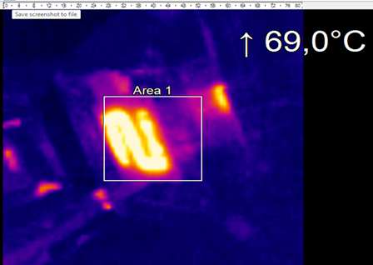
Figure 1: 3D printed injection cavity thermal measure.

Acknowledgments:
The authors thank the DEMIBAV project - Demonstrator of Molds for Injection of Low Volume Plastic Parts, Rota 2030 Program, Line IV - Most Competitive Brazilian Tooling

References:
Vlachopoulos, J., Strutt, D., 2003. “Polymer Processing”. Materials Science and Technology, Vol. 19, pp. 1161-1169. doi.org/10.1179/026708303225004738.

Yang, W., Zhiwei, J., 2009. “Injection moulding of polymers”. Advances in Polymer Processing, pp. 175-203. doi.org/10.1533/9781845696429.2.175.

