Mechanical and water vapor permeation behavior of PLA/PHBV/sepiolite nanocomposites

Aline Vasconcelos Duarteª, Francys Kley Vieira Moreiraª, Juliano Mariniª

ª Federal University of Sao Carlos, Graduate Program in Materials Science and Engineering, São Carlos, Brazil
Email: alinevd@estudante.ufscar.br

Replacing petrochemical polymers with biodegradable ones in disposable applications is one of the alternatives for sustainable development. Poly(lactic acid) (PLA) and poly(hydroxybutyrate-co-valerate) (PHBV) are biodegradable and renewable polymers with potential in the packaging sector, especially when combined in optimal concentrations. The addition of PHBV (20-35 wt%) to PLA can reduce its brittleness and water vapor permeability. However, immiscibility and a tendency for phases to segregate can limit performance, leading to research into compatibilization methods such as the inclusion of nanoparticles. Sepiolite nanoparticles (SEP), for example, can act as a compatibilizer by increasing the interfacial interaction of the polymer phases [1]. In this work, the effect of incorporating SEP (5 phr) in the compatibilization of the PLA/PHBV (70/30) blend was investigated. The blend and nanocomposite were obtained by melt mixing in a Haake Rheomix internal mixer at 180 °C, 100 rpm and 10 min of mixing. Specimens (in the form of films and bars) were compression molded. Mechanical properties were quantified by uniaxial tensile strength (according to ASTM D882) and Izod impact resistance (ASTM D256). Water vapor permeability was determined by the gravimetric method according to ASTM E96. Figure 1 shows the average stress-strain curves (a), impact resistance values (b), and mass change versus time during the permeation tests (c) for the samples.

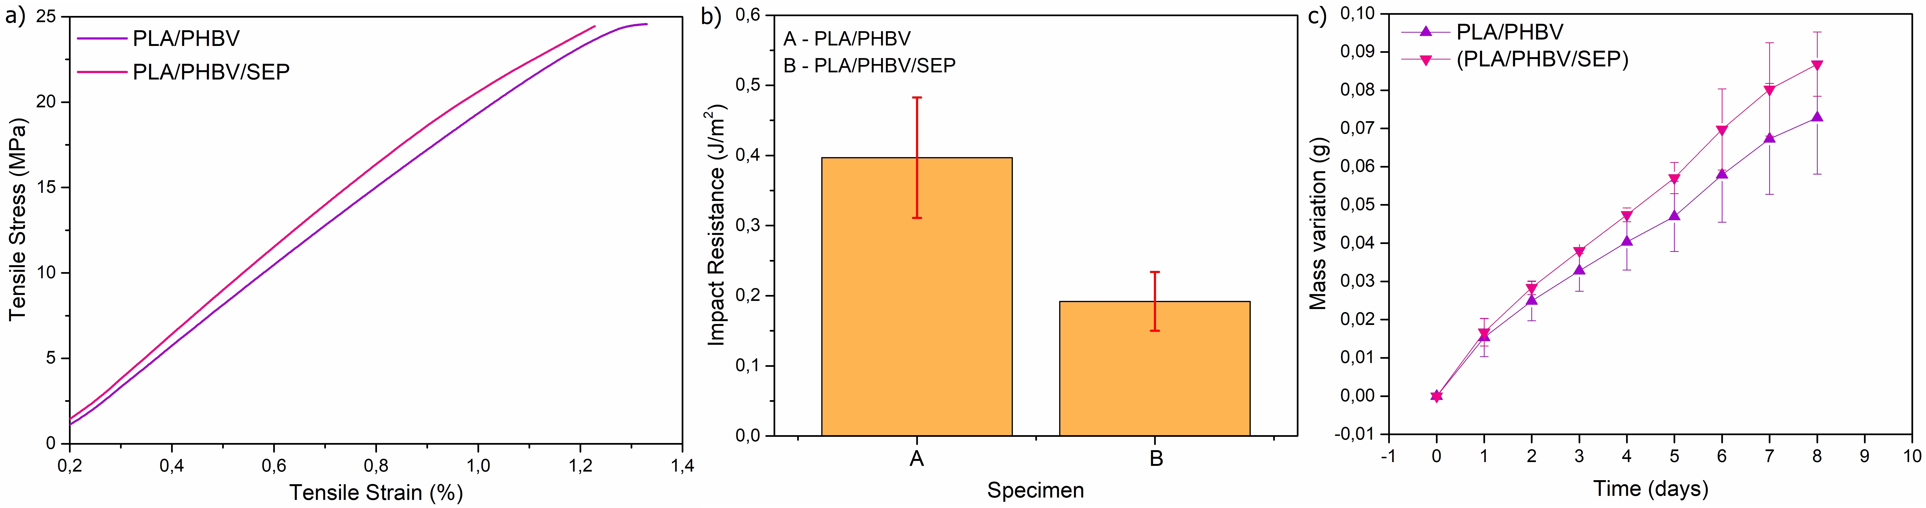
Figure 1. Tensile-strain curves (a), impact resistance (b) and water vapor permeation (c).

The results indicated a reduction in the toughness and impact resistance of the nanocomposite compared to the blend, as well as an increase in the water vapor permeability coefficient, which may be related to the agglomeration of the SEP and its hygroscopicity. Therefore, it is necessary to analyze other mixing protocols aimed at the selective localization of SEP and its chemical surface modification for an effective compatibilizing action of the blend.

Acknowledgments: To the Coordenação de Aperfeiçoamento de Pessoal de Nível Superior - Brazil (CAPES) - Funding Code 001 and to the Conselho Nacional de Desenvolvimento Científico e Tecnológico (CNPq), processes 161342/2021-3 and 407288/2021-0.
References: [1] Ausejo, J. G et al. Effect of the addition of sepiolite on the morphology and properties of melt compounded PHBV/PLA blends, Polym. Compos., v. 40, 2017.

